Year 1 Summer Learning Ideas
To download 3 different Year 1 Maths and English activity books, go to Google Classroom, click ‘Classwork’
and you will see them listed under Maths and English activity books *updated* near the top.
READING AND PHONICS
Please encourage your child to read as much as possible and read a range of reading materials. Reading is crucial to enable them to access all subjects. Check their understanding by asking questions about their reading.
There are lots of free e-books and maths activities on www.oxfordowl.co.uk register for free to access them.
Also www.twinkl.co.uk is offering free access to many resources including maths, phonics and reading materials.
We use https://www.phonicsplay.co.uk/ in school. There are free games available to play.
www.booktrust.org.uk has many activities linked to reading.

ENGLISH AND SPELLINGS
Practice the spellings you have been given this year. Look at the year 1 lists on Purple Mash (search for spellings and then look at year 1). See last page for common and tricky word spellings for year 1.
Grammar, punctuation and spelling: https://www.bbc.co.uk/bitesize/topics/zd63xyc/articles/zdp4pg8
Suggested Writing activities
- Create a summer scrapbook: drawings with labels, photos with sentences to explain what is happening or with speech bubbles, recipes, diary entries, details of places you have visited or games you have played.
- Write a fact file about anything that interests you.
- Record changes in the weather – temperature, rainfall.
- Monitor changes in plants in the garden.
- Do a minibeast hunt and record your findings.
- Write instructions for an arts and crafts activity
Handwriting: practice writing cursive letters. Are small letters the same size and sitting on the line? Are tail letters going below the line and ladder letters are tall? Handwriting books have been brought home with extra handwriting practice lines.

MATHS
Play games that involve numbers, such as bingo, dice, card games, dominoes and board games. Snakes and ladders and monopoly are excellent for learning number bonds to 10.
Play online games for adding/subtracting numbers within 20, or counting games to 100.
Online sites:
https://www.topmarks.co.uk/maths-games/hit-the-button
https://www.topmarks.co.uk/maths-games/mental-maths-train
https://www.purplemash.com/sch/ashwell go to Maths then scroll down to games.
https://mathszone.co.uk/tag/ks1/
https://mathsframe.co.uk/
www.twinkl.co.uk lots of free maths resources, including a couple of KS1 maths mysteries, but you have to pay to get full access.
MUSIC
www.bbc.co.uk > teach > bringthenoise > found-sounds
Watch the short videos about the sounds YolanDa Brown finds in different places. See what interesting things you can find at home that make different sounds. If you would like to you could try to make some of the instruments like The Mighty Music Makers or just have fun watching what they do.
Book List
Some children may be ready for chapter books, for you to read to them, or to read alone if they are able, but they will struggle with comprehension in some cases so it’s a good idea to talk to them about the story as much as you can. Here are some suggestions:
Horrid Henry series (Francesca Simon)
Mr Gum series (Andy Stanton)
The Worst Witch series (Jill Murphy)
Dirty Bertie series (Alan MacDonald)
The Treehouse series (Andy Griffiths)
The Boy Who Grew Dragons (Andy Shepherd)
The Owl Who Was Afraid of the Dark, and more (Jill Tomlinson)
The Hodgeheg, The Sheep-Pig, and more (Dick King-Smith)
Charlotte’s Web (EB White)
The Twits, George’s Marvellous Medicine, The Magic Finger, etc (Roald Dahl)
Flat Stanley (Jeff Brown)
The Diary of a Killer Cat, Bill’s New Frock, etc (Anne Fine)
The Hundred-Mile-An-Hour Dog, and more (Jeremy Strong)
Books by the Ahlbergs: the Gaskitts books are very funny and children also love the Happy Families series.

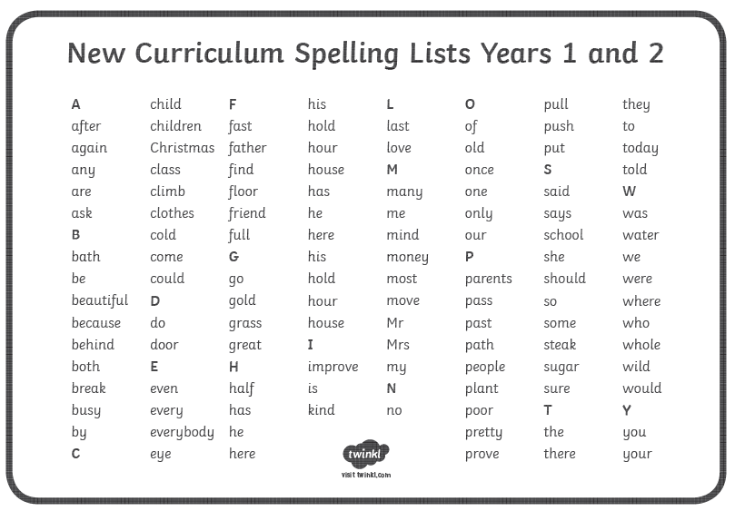

Year 1 Tricky Words
the | is | no | one
a | his | go | once
do | has | so | ask
to | you | by | friend
today | your | my | school
of | they | here | put
said | be | there | push
says | he | where | pull
are | me | love | full
were | she | come | house
was | we | some | our

